Name: Karanveer Singh Multani
Registration number: 11803142
GitHub: github.com/Nocturnal1401/Student-Faculty-Query-Scheduler

CSE 316
Operating Systems

Question statement:
Sudesh Sharma is a Linux expert who wants to have an online system where he can handle student queries. Since there can be multiple requests at any time he wishes to dedicate a fixed amount of time to every request so that everyone gets a fair share of his time. He will log into the system from 10am to 12am only. He wants to have separate requests queues for students and faculty, where faculty queue is given a higher priority. Implement a strategy for the same. The summary at the end of the session should include the total time he spent on handling queries and average query time.
Approach:
Sudesh Sharma’s task is to resolve queries in the order they come in. But, he is also has to prioritize queries by the faculty. Hence, the queries by students will be pushed back. If we carefully observe the question statement we notice that Mr Sharma’s task is something similar to Process scheduling carried out in OS, where Mr Sharma is the CPU and has to carry out the processes. The statement, “he wishes to dedicate a fixed amount of time to every request” shows us that each process or query in this case will be allowed to run for a set equal amount of time before he swaps/switches to a different query. Round robin is one such process scheduling algorithm which allocates resources and allows the processes to run for equal amounts of time. Also he is only logging onto the system for 10 am to 12 am, that means any query that comes before 10 am or after 12 am should not be allowed to be executed.
A structure that represented that the basic attributes of a query was made and it had 3 different types of variables. One for faculty, student and a merged one with both faculty and student query arranged according to priority. Round robin scheduling was later applied on this merged queue.
Assumptions:
Not more than 1000 queries from either faculty or student were needed to be dealt with at one point of execution.

Code:
#include<stdio.h>
#include<stdbool.h>
struct querie
{
int pid;//process id
int at;//arrival time of process
int bt;//burst time of process
int rt;//remaing time of process
int wt;//wait time of process
int tt;//turnaround time of process
}f[1000],s[1000],m[2000]; //faculty queue, student queue, merged queue

int fc=0,sc=0,mc=0;//faculty counter, student counter, merged queue counter
int n,time;//nuber of processes, total time of execution
int total_waiting_time=0,total_turnaround_time=0;

void input()
{
int type;
printf("Please enter the number of processes:");
scanf("%d",&n);
int i;
for(i=0;i<n;i++)
{
printf("\n\t***Enter 1 for faculty querie and 2 for student querie***\n");
printf("\nType(1/2):");
scanf("%d",&type);
if(type==1)
{
f[fc].pid = i;
printf("\nEnter the arrival time and burst time\n");
printf("\nFormat for arrival time 0000 hrs (For example 11:45 as 1145)\n");
printf("\nArrival time:");
scanf("%d",&f[fc].at);
if(f[fc].at<1000 || f[fc].at>1200)
{
printf("\n\t***Enter a valid arrival time***\n\n");
i--;//if we decrement i and continue, we are basically letting the user to go back to same iteration of i
continue;
}
printf("\nEnter the amount of burst time(in mins)\n");
printf("\nBurst time:");
scanf("%d",&f[fc].bt);
f[fc].rt=f[fc].bt;
fc++;
}
else if(type==2)
{
s[sc].pid = i;
printf("\nEnter the arrival time and burst time\n");
printf("\nFormat for arrival time 0000 hrs (For example 11:45 as 1145)\n");
printf("\nArrival time:");
scanf("%d",&s[sc].at);
if(s[sc].at<1000 || s[sc].at>1200)
{
printf("\n\t***Enter a valid arrival time***\n\n");
i--;//if we decrement i and continue, we are basically letting the user to go back to same iteration of i
continue;
}
printf("\nEnter the amount of burst time(in mins)\n");
printf("\nBurst time:");
scanf("%d",&s[sc].bt);
s[sc].rt=s[sc].bt;
sc++;
}
else {
printf("\n***Plese enter a valid type for querie***\n");
i--;//if we decrement i, we are basically letting the user to go back to same iteration of i
}
}
}

void merged_queue()
{
int ifc=0,isc=0;//faculty iterator, student iterator
if(fc!=0 && sc !=0)
{
while(ifc<fc && isc<sc)//since at the end of loop we will have either ifc == fc or isc == sc and neither f[ifc] nor s[isc] will exist and will throw error
{
if(f[ifc].at == s[isc].at)
{
m[mc]=f[ifc];
ifc++;
mc++;
}
else if(f[ifc].at>s[isc].at)
{
m[mc]=s[isc];
isc++;
mc++;
}
else if(f[ifc].at<s[isc].at)
{
m[mc]=f[ifc];
ifc++;
mc++;
}
}
if(fc==ifc)
{
while(isc!=sc)
{
m[mc]=s[isc];
isc++;
mc++;
}
}
else if(sc==isc)
{
while(ifc!=fc)
{
m[mc]=f[ifc];
ifc++;
mc++;
}
}
}

else if(fc==0)//if no faculty query exists
{
while(isc!=sc)
{
m[mc]=s[isc];
isc++;
mc++;
}
}
else if(sc==0)//if no student query exists
{
while(ifc!=fc)
{
m[mc]=f[ifc];
ifc++;
mc++;
}
}
}

void round_robin()
{
int time_quantum;
int left=n;//number of unresolved queries left
bool idle=0;//CPU idle status
printf("\nEnter the time quantum:");
scanf("%d",&time_quantum);
printf("\n\n\t***Order of execution***\n");
for(time=m[0].at,mc=0;left!=0;)//loop until no unresolved query is left
{

if(m[mc].rt<=time_quantum && m[mc].rt!=0)//if remaining time is less than time quantum
{
time += m[mc].rt;
m[mc].rt = 0;
idle=1;
m[mc].wt += time-(m[mc].at+m[mc].bt);
m[mc].tt += time-(m[mc].at);
total_waiting_time += m[mc].wt;
total_turnaround_time += m[mc].tt;
left--;
printf("%d ",m[mc].pid);
}
else if(m[mc].rt>time_quantum)//if remaining time is greater than time quantum
{
time += time_quantum;
m[mc].rt -= time_quantum;
printf("%d ",m[mc].pid);
idle=0;
}

if(mc==n-1)//if merged queue counter is at the last process
{
mc = 0;
}
else if(m[mc+1].at<time)//if next process has already arrived
{
mc++;
}
else if(idle == 1 && m[mc+1].at>time && m[mc-1].rt==0)//if CPU idle and previous processes have already executed, then jump to next process
{
time = m[mc+1].at;
mc++;
}
else
{
mc = 0;
}
}
}

void display()
{
int i;
printf("\nProcess id | Burst Time | Arrival Time | Waiting Time | Turnaround Time\n");
for(i=0;i<n;i++)
{
printf("\n%d\t\t%d\t\t%d\t\t%d\t\t%d",m[i].pid,m[i].bt,m[i].at,m[i].wt,m[i].tt);
}
printf("\n\n\nTotal time spent:%d", (time-m[mc].at));
printf("\nAverage waiting time:%d",(total_waiting_time/n));
printf("\nAverage turnaround time:%d",(total_turnaround_time/n));
}

void main()
{
input();
merged_queue();
round_robin();
printf("\n");
display();
printf("\n\n\t***Finished scheduling***");
}
Snapshots:
Example 1
- For this example, we have taken 3 processes with same arrival time
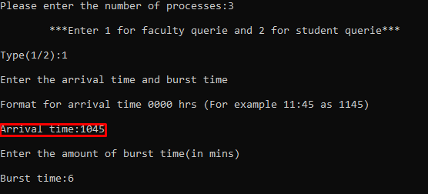
- First process(pid 0) is of type 1 i.e. Faculty

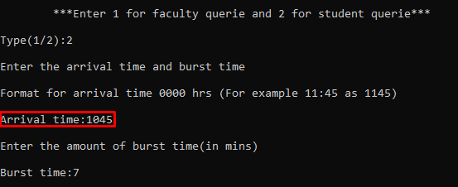
- Second process(pid 1) is of type 2 i.e. Student
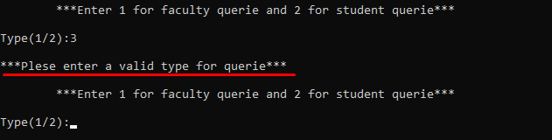
- If invalid query type is entered an error message is displayed
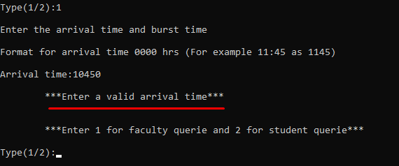
- If invalid arrival time is entered an error message is displayed
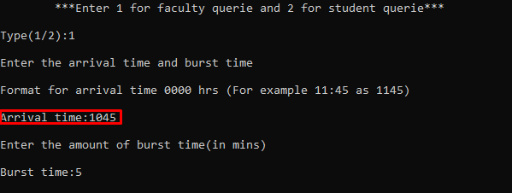
- Third process(pid 2) is of type 1 i.e. Faculty
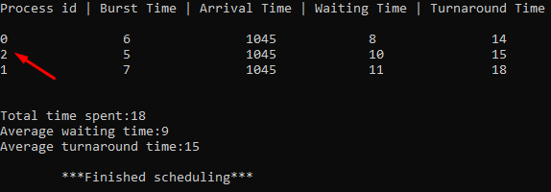
- Result
- Explanation
- P0, P1 and P2 enter the merged queue. The time quantum for round robin scheduling was 2 time units.

- First P0 executes for 2 time units as it has higher priority as it was entered first even though it arrived at the same time. 2 time units are added to P2’s and P1’s wait time as they both have already arrived. P0 is left with only 4 time units of execution.

- P0 remaining time = 4 P0 wait time = 0
- P1 remaining time = 7 P1 wait time = 2
- P2 remaining time = 5 P2 wait time = 2

- After execution of P0, P2 is executed since it has higher priority over P1. P2 executes for 2 time units. 2 time units are added to P0’s and P1’s wait time as they both have already arrived. P2 is left with only 3 time units of execution.

- P0 remaining time = 4 P0 wait time = 2
- P1 remaining time = 7 P1 wait time = 4
- P2 remaining time = 3 P2 wait time = 2

- Finally, P1 executes for 2 time units. 2 time units are added to P0’s and P2’s wait time as they both have already arrived. P1 is left with only 5 time units of execution.

- P0 remaining time = 4 P0 wait time = 4
- P1 remaining time = 5 P1 wait time = 4
- P2 remaining time = 3 P2 wait time = 4

- P0 executes for 2 time units. 2 time units are added to P1’s and P2’s wait time.P0 is left with only 2 time units of execution.

    - P0 remaining time = 2 P0 wait time = 4
    - P1 remaining time = 5 P1 wait time = 6
    - P2 remaining time = 3 P2 wait time = 6

- P2 executes for 2 time units. 2 time units are added to P1’s and P0’s wait time.P2 is left with only 1 time units of execution.

    - P0 remaining time = 2 P0 wait time = 6
    - P1 remaining time = 5 P1 wait time = 8
    - P2 remaining time = 1 P2 wait time = 6

- P1 executes for 2 time units. 2 time units are added to P2’s and P0’s wait time .P1 is left with only 3 time units of execution.

    - P0 remaining time = 2 P0 wait time = 8
    - P1 remaining time = 3 P1 wait time = 8
    - P2 remaining time = 1 P2 wait time = 8

- P0 executes for 2 time units. 2 time units are added to P2’s and P1’s wait time.P0 is left with only 0 time unit of execution.

    - P0 remaining time = 0 P0 wait time = 8
    - P1 remaining time = 3 P1 wait time = 10
    - P2 remaining time = 1 P2 wait time = 10

- P2 executes for 1 time unit. 1 time unit is added to P1’s wait time as .P2 is left with only 0 time unit of execution.

    - P0 remaining time = 0 P0 wait time = 8
    - P1 remaining time = 3 P1 wait time = 11
    - P2 remaining time = 0 P2 wait time = 10

- P1 executes for 2 time units. P1 is left with only 1 time unit of execution.

    - P0 remaining time = 0 P0 wait time = 8
    - P1 remaining time = 1 P1 wait time = 11
    - P2 remaining time = 0 P2 wait time = 10

- P1 executes for 1 time unit. P1 is left with only 0 time unit of execution.

    - P0 remaining time = 0 P0 wait time = 8
    - P1 remaining time = 0 P1 wait time = 11
    - P2 remaining time = 0 P2 wait time = 10
Example 2
- This time we have 5 queries
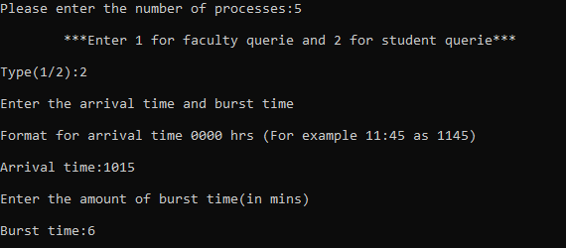
- First query
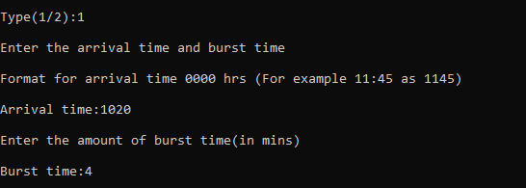
- Second query
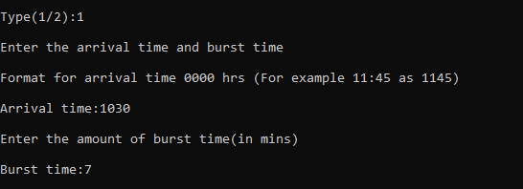
- Third query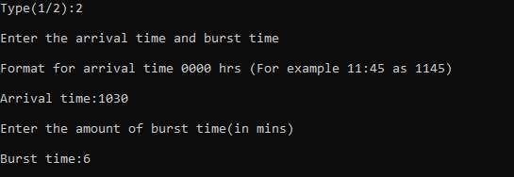
- Fourth query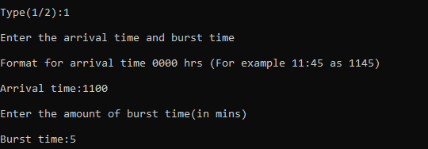
- Fifth query
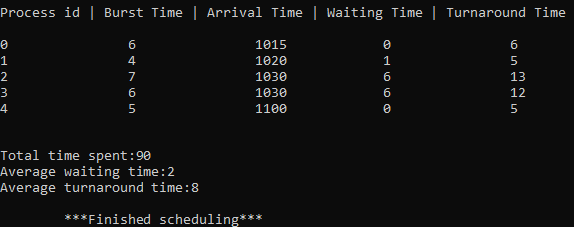
- Result
- Explanation
- P0, P1, P2, P3 and P4 enter the merged queue. The time quantum for round robin scheduling was 2 time units.
- First P0 executes for 2 time units as it arrived first and there is no other process with higher priority. P0 is left with only 4 time units of execution.
- P0 remaining time = 4 P0 wait time = 0
- P1 remaining time = 4 P1 wait time = 0
- P2 remaining time = 7 P2 wait time = 0
- P3 remaining time = 6 P1 wait time = 0
- P4 remaining time = 5 P2 wait time = 0

- P0 executes for 2 time units. P0 is left with only 2 time units of execution.
- P0 remaining time = 2 P0 wait time = 0
- P1 remaining time = 4 P1 wait time = 0
- P2 remaining time = 7 P2 wait time = 0
- P3 remaining time = 6 P1 wait time = 0
- P4 remaining time = 5 P2 wait time = 0
- P0 executes for 2 time units. P1 has also arrived but it has to wait for 1 time unit. P0 is left with only 0 time units of execution.
- P0 remaining time = 0 P0 wait time = 0
- P1 remaining time = 4 P1 wait time = 1
- P2 remaining time = 7 P2 wait time = 0
- P3 remaining time = 6 P1 wait time = 0
- P4 remaining time = 5 P2 wait time = 0
- P1 executes for 2 time units. P1 is left with only 2 time units of execution.
- P0 remaining time = 0 P0 wait time = 0
- P1 remaining time = 2 P1 wait time = 1
- P2 remaining time = 7 P2 wait time = 0
- P3 remaining time = 6 P1 wait time = 0
- P4 remaining time = 5 P2 wait time = 0
- P1 executes for 2 time units. P1 is left with only 0 time units of execution.
- P0 remaining time = 0 P0 wait time = 0
- P1 remaining time = 0 P1 wait time = 1
- P2 remaining time = 7 P2 wait time = 0
- P3 remaining time = 6 P1 wait time = 0
- P4 remaining time = 5 P2 wait time = 0
- First P2 executes for 2 time units as it has higher priority than P3. 2 time units are added to P3 wait time as it has already arrived. P2 is left with only 5 time units of execution.
- P0 remaining time = 0 P0 wait time = 0
- P1 remaining time = 2 P1 wait time = 1
- P2 remaining time = 5 P2 wait time = 0
- P3 remaining time = 6 P1 wait time = 2
- P4 remaining time = 5 P2 wait time = 0
- P3 executes for 2 time units. 2 time units are added to P2 wait time. P3 is left with only 4 time units of execution.
- P0 remaining time = 0 P0 wait time = 0
- P1 remaining time = 2 P1 wait time = 1
- P2 remaining time = 5 P2 wait time = 2
- P3 remaining time = 4 P1 wait time = 2
- P4 remaining time = 5 P2 wait time = 0
- P2 executes for 2 time units. 2 time units are added to P3 wait time. P2 is left with only 3 time units of execution.
- P0 remaining time = 0 P0 wait time = 0
- P1 remaining time = 2 P1 wait time = 1
- P2 remaining time = 3 P2 wait time = 2
- P3 remaining time = 4 P1 wait time = 4
- P4 remaining time = 5 P2 wait time = 0
- P3 executes for 2 time units. 2 time units are added to P2 wait time. P3 is left with only 2 time units of execution.
- P0 remaining time = 0 P0 wait time = 0
- P1 remaining time = 2 P1 wait time = 1
- P2 remaining time = 3 P2 wait time = 4
- P3 remaining time = 2 P1 wait time = 4
- P4 remaining time = 5 P2 wait time = 0
- P2 executes for 2 time units. 2 time units are added to P3 wait time. P2 is left with only 1 time unit of execution.
- P0 remaining time = 0 P0 wait time = 0
- P1 remaining time = 2 P1 wait time = 1
- P2 remaining time = 1 P2 wait time = 4
- P3 remaining time = 2 P1 wait time = 6
- P4 remaining time = 5 P2 wait time = 0
- P3 executes for 2 time units. 2 time units are added to P2 wait time. P3 is left with only 0 time unit of execution.
- P0 remaining time = 0 P0 wait time = 0
- P1 remaining time = 2 P1 wait time = 1
- P2 remaining time = 3 P2 wait time = 6
- P3 remaining time = 0 P1 wait time = 6
- P4 remaining time = 5 P2 wait time = 0
- P2 executes for 1 time unit. P2 is left with only 0 time unit of execution.
- P0 remaining time = 0 P0 wait time = 0
- P1 remaining time = 2 P1 wait time = 1
- P2 remaining time = 0 P2 wait time = 6
- P3 remaining time = 0 P1 wait time = 6
- P4 remaining time = 5 P2 wait time = 0
- P4 executes for 2 time units. P2 is left with only 3 time units of execution.
- P0 remaining time = 0 P0 wait time = 0
- P1 remaining time = 2 P1 wait time = 1
- P2 remaining time = 0 P2 wait time = 6
- P3 remaining time = 0 P1 wait time = 6
- P4 remaining time = 3 P2 wait time = 0
- P4 executes for 2 time units. P2 is left with only 1 time unit of execution.
- P0 remaining time = 0 P0 wait time = 0
- P1 remaining time = 2 P1 wait time = 1
- P2 remaining time = 0 P2 wait time = 6
- P3 remaining time = 0 P1 wait time = 6
- P4 remaining time = 3 P2 wait time = 0
- P4 executes for 1 time unit. P2 is left with only 0 time unit of execution.
- P0 remaining time = 0 P0 wait time = 0
- P1 remaining time = 2 P1 wait time = 1
- P2 remaining time = 0 P2 wait time = 6
- P3 remaining time = 0 P1 wait time = 6
- P4 remaining time = 0 P2 wait time = 0

